MINISTRY OF GENERAL EDUCATION
I/SCIENCE LESSON PLAN
NAME OF TEACHER:________________________ SCHOOL:_____________________
GRADE | TOPIC | SUB TOPIC | DURATION | DATE
8 | REFLECTION AND REFRACTION OF LIGHT | REFRACTION | ____min | ____/___/__
ATTENDANCE: Boys:______ Girls:_______ Total:_____
TEACHING/ LEARNING AIDS : Lab Apparatus, Chalk board, Learners books and Charts.
REFERENCES : I/Science Progress book 8, I/Science Study kits 2018.
RATIONALE: This is lesson number one on Reflection and Refraction of light. It will help learners acquire skills and values of how to determine the types of heat transfer. Group work, discussion, demonstration and Question & Answer methods will be used to execute the lesson.
PRE-REQUISITE SKILLS/ KNOWLEDGE: learners have ideas about a Reflection of light.
SPECIFIC OUTCOMES, LSBAT:
- Define the term Refraction of light
- Investigate the characteristics of refraction.
- Describe the application of reflection and refraction to daily life.
STAGE | CONTENT | TEACHERS ACTIVITY | PUPILS ACTIVITY | METHODS
INTRODUCTION  ____min | Recap on previous lesson  Reflection  - Reflection is the bouncing of light off a smooth surface.  - Light that bounces off a smooth surface such as a mirror is reflected in a regular way while light bouncing off a rough surface is reflected in an irregular way. | Teacher asks random questions during the introduction | Pupils respond and participate | Brainstorm
D  E  V  E  L  O  P  M  E  N  T  ___min | Refraction  - Refraction is the bending or changing of direction of light rays when they pass from one material into another. Refraction takes place at the boundary of the two media (singular – medium).  - When light passes from a less dense medium to a denser medium, it is refracted towards the normal.  - Light travelling from a denser medium to a less dense medium is refracted away from the normal.  - However, whether light is from a less dense medium to a denser medium, or vice versa, refraction will not occur if it strikes the surface at right angles as shown in figure (c) below.0.21  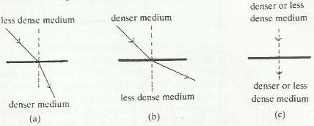  Identify the real and apparent depths of an object under water.  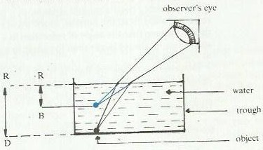  Note: light from point D is refracted away from the normal at the water surface. Light reaching the observer appears to come from point B, which is directly above point D. the object D appears to be in position B. thus RB is its apparent depth. The true or real depth is RD since the coin has not been raised. The apparent depths are always less than the real depths of the object.  The application of reflection and refraction.  - Reflection is applied in:  - Searchlights  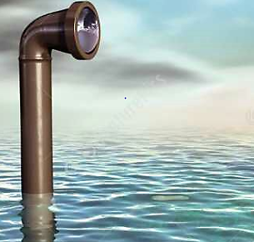  - Headlamps  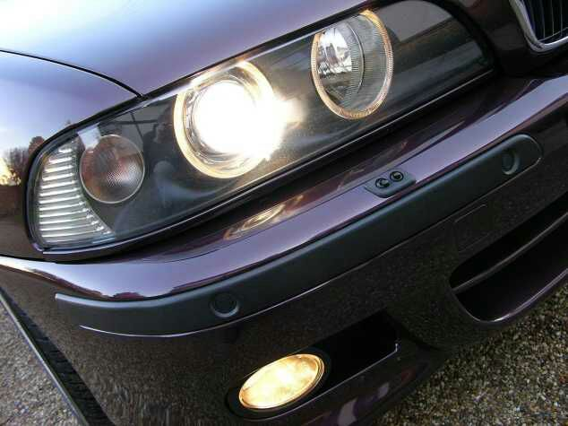  - Magnifying mirrors  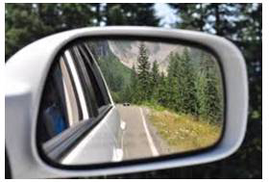  Refraction is applied in lenses of instruments such as camera, binoculars, telescope, spectacles and microscope. | Teacher explains the details to the learners  Teacher puts pupils in groups to discuss  Teacher writes brief notes on the board | Pupils listen and ask questions  Learners discuss and bring out main points  Pupils copy the notes in their books | Teachers  Exposition  Group  work  Individual  Work
PRACTICAL EXERCISE
- Define the term Refraction of light
- Investigate the characteristics of refraction.
- Describe the application of reflection and refraction to daily life.
PUPILS EVALUATION
………………………………………………………………………………………………………TEACHERS EVALUATION
..........................................................................................................................................................

